Indian Missiles Pushing Ahead with Precision and Reach
Air Marshal Anil Chopra, PVSM, AVSM, VM, VSM (Retd)

Byline:
India has a great and growing package of indigenous missiles. The nation is using leading edge technologies and employs a blend of indigenous missiles and imported systems for a comprehensive air defence and offensive options.
On May 8, 2026, India successfully flight-tested an advanced Agni-5 missile equipped with Multiple Independently Targeted Re-entry Vehicle (MIRV) technology from Dr APJ Abdul Kalam Island, Odisha. This test (Mission Divyastra sequel) enables a single missile to deliver multiple nuclear warheads to different targets, significantly enhancing India's strategic deterrence. India’s Defence Research and Development Organisation (DRDO) had earlier given the Agni-V ballistic missile a powerful upgrade with bunker-buster capability to achieve penetration through a combination of high mass, hardened casings, and advanced guidance systems. It will reportedly carry a massive 7,500-kilogram conventional warhead, at hypersonic speeds (Mach 8–20), and is designed to penetrate 80–100 meters of reinforced concrete or rock.

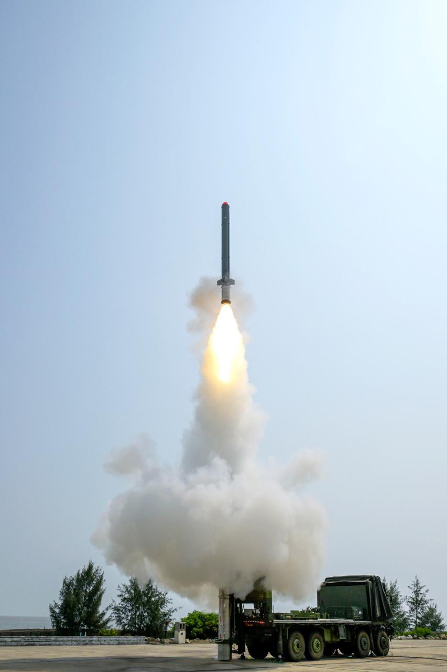
India boasts a portfolio of globally competitive defence and weapons programs., driven by DRDO and private industry, and they are rapidly advancing indigenous defence capabilities and pushing the nation towards self-reliance. Key programs include the BrahMos supersonic cruise missile, Agni Intercontinental Ballistic Missile (ICBM), the two-tiered Ballistic Missile Defence system, placing India among the top global military technology powers. India ran an Integrated Guided Missile Development Program (IGMDP) to build basic capabilities and create a technology development launch pad. The Astra air-to-air missile (AAM) program is developing world-class variants. Moreover, India's indigenous surface-to-air missile (SAM) systems feature the versatile Akash series for medium-range defence and various specialized systems for short-range and quick-reaction needs.

Integrated Guided Missile Development Program
The IGMDP was India's ambitious, indigenous effort starting in the 1980s, led by Dr A.P.J. Abdul Kalam, “Missile Man of India”, to achieve self-reliance in missile technology. Managed by DRDO, it successfully birthed strategic missiles and significantly advanced India's defence capabilities, despite facing challenges like technical complexities and cost overruns. The objective was to create a comprehensive range of missiles for India's defence needs, reducing reliance on foreign technology and enhancing national security and deterrence. The program focused on five core systems: the “Prithvi” surface-to-surface tactical missile (SSM); Agni surface-to-surface strategic missile (longer range); Trishul short-range SAM; Akash medium-range SAM; and the Nag anti-tank guided missile (ATGM). The program conferred significant capabilities and technological prowess, making India a major missile power, culminating in advanced missiles like Agni-V and BrahMos. With its objectives largely met, the IGMDP was wound down in 2008, and India transitioned into further advanced missile programs.

Agni Missile Program
The Agni missile program is India's premier long-range, nuclear-capable surface-to-surface ballistic missile series. It provides a critical deterrent with missiles ranging from 700 km to over 5,000 km. The missiles are solid-fuelled, road-mobile, and designed for high precision, with later versions featuring canisterisation for faster launch capabilities. The Agni-V and beyond provide ICBM capabilities, with the ability to carry MIRV. The Agni missile variants are Agni-I (700-800 km, short-range, single-stage missile); Agni-II (2,000+ km medium-range, two-stage missile); Agni-III (3,000+ km intermediate-range, heavier payloads); Agni-IV (3,500+ km, modern avionics, road-mobile); Agni-V (5,000+ km ICBM, three-stage solid propellant); Agni-P (Prime) (1,000-2,000 km, advanced next-gen, canister-based) are all operational. Agni-VI is under development and will have a range of nearly 12,000 km and an enhanced payload. The program has put India in an elite group with advanced, long-range, and MIRV-capable strike capabilities. Countries with operational ICBMs (range 5,500+) include the United States, Russia, China, India, France, the United Kingdom, and North Korea, with some sources also mentioning Israel, while other nations like Iran possess long-range missiles but don’t have nuclear warheads.
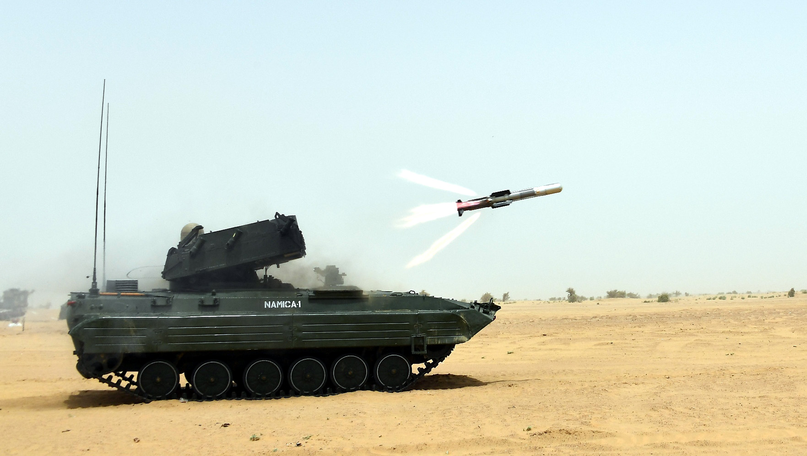

K-series SLBMs (K-15, K-4, and K-5)
India's K-series SLBMs are designed by DRDO to build a robust sea-based nuclear deterrent (nuclear triad). The family includes the operational K-15 (750 km), the operational K-4 (~3,500 km), and the under-development/tested K-5 (5,000+ km), which can be launched from the Arihant-class submarines. Short-range K-15 is designed for quick retaliation. K-4 boosts strategic strike capability significantly. K-5 gives strategic range to target far-off threats while staying in secured, deep-water locations. Future Variants include the K-6 (6,000–8,000 km) and further, ensuring the ability to strike targets without leaving the Indian Ocean. The K-series strengthens India's “no first use” policy, enabling a credible second-strike capability from submarines. While the INS Arihant initially carried the shorter-range K-15, the later submarines can carry multiple K-4 missiles, and the future K-5 will significantly extend India’s coverage over potential adversary territories.

India’s Indigenous Tactical SSM
India has developed a robust arsenal of indigenous tactical SSMs to ensure battlefield dominance and credible deterrence. These systems focus on high precision, quick reaction times, and the ability to carry conventional or tactical nuclear warheads. The “Prithvi” series includes Prithvi-I (150 km for Army), and Prithvi-II (350 km), single-stage liquid-fuelled missile used primarily by the Indian Air Force (IAF). “Dhanush” (1,000Kg, 750 km) is a ship-launched, sea-worthy version of the Prithvi missile. Shaurya is a canister-launched hypersonic surface-to-surface missile capable of manoeuvring at speeds above Mach 5, offering a rapid strike capability. “Pralay” (150–500 km) is a canisterised, solid-fuel, battlefield missile developed to replace older tactical systems like the Prithvi. “Prahaar” (150 km) is a quick-reaction, all-weather, high-precision missile to fill the gap between multi-barrel rocket systems and long-range ballistic missiles. The operational focus is on “cold start” capabilities, rapid, high-accuracy strikes in low-intensity conflicts. Transitioning from liquid to solid fuel for faster deployment and enhanced stealth in cruise missiles.

Nirbhay Cruise Missile
Nirbhay is India's first indigenously developed long-range, subsonic cruise missile designed by the DRDO to strike targets up to 1,000 km away, flying atspeed 0.6 - 0.7Mach. It is a versatile, all-weather missile capable of carrying conventional and nuclear warheads, utilizing sea-skimming technology to evade enemy radar, often termed the “Indigenous Technology Cruise Missile (ITCM)”. It uses a solid rocket booster for take-off and a turbofan engine (Manik) for cruising. It has loitering capability for target selection. Land-based mobile launcher is TATA LPTA 5252-12 X 12. There are plans for submarine deployment. The project has been developed by the Aeronautical Development Establishment (ADE), Bengaluru, and strengthens India's defence capabilities alongside the supersonic BrahMos missile.
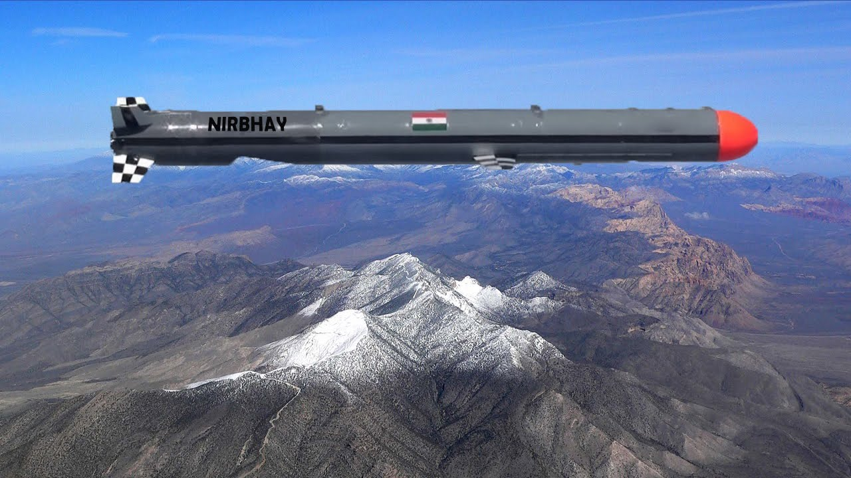

LR-LACM
The Long Range-Land Attack Cruise Missile (LR-LACM) is a longer-range variant of the Nirbhay with a range up to 1,500 km. As its primary user, the Indian Navy is collaborating with the Indian Air Force (IAF) in the design, development, and acquisition of LR-LACM and associated equipment. It would be compatible with the Universal Vertical Launch Module (UVLM) cells used for BrahMos by the Navy on frontline warships. It will weigh about one tonne, have a length of 6 m and a diameter of 0.52 m. The missile is designed to have two tapering-chord fold-out wings with a span of 2.7 m. Successfully tested in late 2024, the Indian Navy is expected to order roughly 200 missiles, worth approximately Rs 5,000 crore. Meanwhile, the Defence Acquisition Council (DAC) approved the procurement of the missile for the Indian Army and the IAF in February 2024 and November 2023 at the cost of ₹4,000 crore (US$420 million) and ₹10,000 crore (US$1.1 billion), respectively.

NASM-SR
The Naval Anti-Ship Missile-Short Range (NASM-SR) is India’s first indigenous air-launched anti-ship missile, developed by DRDO for the Indian Navy. It is a 55 km range, Mach 0.8 missile designed to replace the Sea Eagle on helicopters like the MH-60R. It features a solid propulsion booster, a long-burn sustainer, advanced navigation, sea-skimming capability, and Imaging Infrared (IIR) homing. The missile carries a 100 kg warhead and is designed for high precision in coastal and littoral warfare. On April 29, 2026, the DRDO and Indian Navy successfully conducted the maiden salvo launch of two NASM-SR missiles from a Sea King Mk. 42B helicopter, achieving direct hits on targets. While primarily designed for helicopters, it can be adapted to be launched from ships and land-based vehicles.

LR-AShM
The Long Range Anti-Ship Missile (LR-AShM) is an indigenous Indian hypersonic glide weapon designed for the Indian Navy to engage high-value targets like aircraft carriers at ranges over 1,500 km. Developed by DRDO, it features a two-stage solid rocket motor, reaches speeds of Mach 10, and utilizes a “skip-glide” trajectory to evade radar detection. It has been successfully tested and is in limited production, with trials ongoing. Future iterations will target greater ranges. It will greatly enhance India's A2/AD (Anti-Access/Area Denial) capabilities, often dubbed a “carrier-killer”, the missile employs advanced inertial navigation, multi-GNSS, and terminal Active Radar Homing (ARH).

SMART
The Supersonic Missile-Assisted Release of Torpedo (SMART) is a next-generation, canister-based missile system developed by DRDO to bolster the Indian Navy's anti-submarine warfare (ASW) capabilities. It functions as a hybrid weapon, acting as a supersonic missile that carries a lightweight torpedo to strike submarines far beyond conventional torpedo range. Launched from a warship or truck-based coastal battery, it flies at supersonic speeds, guided by a two-way data link, before releasing its torpedo payload close to the target. Specifically designed for long-range, high-precision ASW. Successfully tested by DRDO, with recent tests confirming its reliability as a major breakthrough for maritime strategic capabilities.

BrahMos Variants
The BrahMos is a long-range, ramjet-powered supersonic cruise missile that can be launched from submarines, ships, and fighter aircraft. It is among the world’s fastest cruise missiles, operating at Mach 2.8. It is a joint venture between India's DRDO and the Russian Federation's NPO Mashinostroyeniya, which together have formed BrahMos Aerospace. The missile is based on P-800 Oniks. Land-launched, ship-launched as well as air-launched versions have been inducted across the Indian Armed Forces. The missile guidance has been developed by BrahMos Aerospace. In 2016, after India joined the Missile Technology Control Regime (MTCR), the range of the missile was gradually enhanced. The future hypersonic missile (Mach 8), designated as the BrahMos-II, is based on the Russian 3M22 Zircon. Ship or Land based missiles have a range of 800–900 km, air-launched has 450–500 km, and the export variant has 290 km. Accuracy is less than 1 m CEP. 1500 km-plus range missiles are evolving. BrahMos-NG (Next Generation) is a shortened version. It will have a range of 290 km and a speed of Mach 3.5 and will weigh around 1.5 tons. The Su-30 MKI will carry three of these. Mikoyan MiG-29K, HAL Tejas Mk1A (later Mk2), and Dassault Rafale will carry one each. The submarine-launched variant will be capable of being fired from the new P75I class of submarines.

Anti-Tank Guided Missile (ATGM)
HELINA (Dhruvastra) is an abbreviation for Helicopter-launched NAG. It is a third-generation fire-and-forget anti-tank guided missile (ATGM) for helicopters like the HAL Rudra, which are equipped with 2 Twin launchers, one on either side, carrying a total of 8 missiles. HELINA is equipped with a High-Resolution Imaging Infrared Seeker (IIR) capable of automatic target detection and tracking in adverse weather conditions. Manufactured by BDL, it has a max range of 7,000 m. The attack modes are top-down and direct. The SANT (Stand-off Anti-Tank) missile is an advanced, 4th-generation, indigenous air-to-surface weapon developed by DRDO's RCI for the IAF. It is an upgraded, helicopter-launched version of the HELINA weapon system. It features a, millimetre-wave (MMW) seeker, allowing for high-precision strikes against armoured targets from a safe stand-off distance of up to 10 km. It features both lock-on before launch and lock-on after launch capabilities.
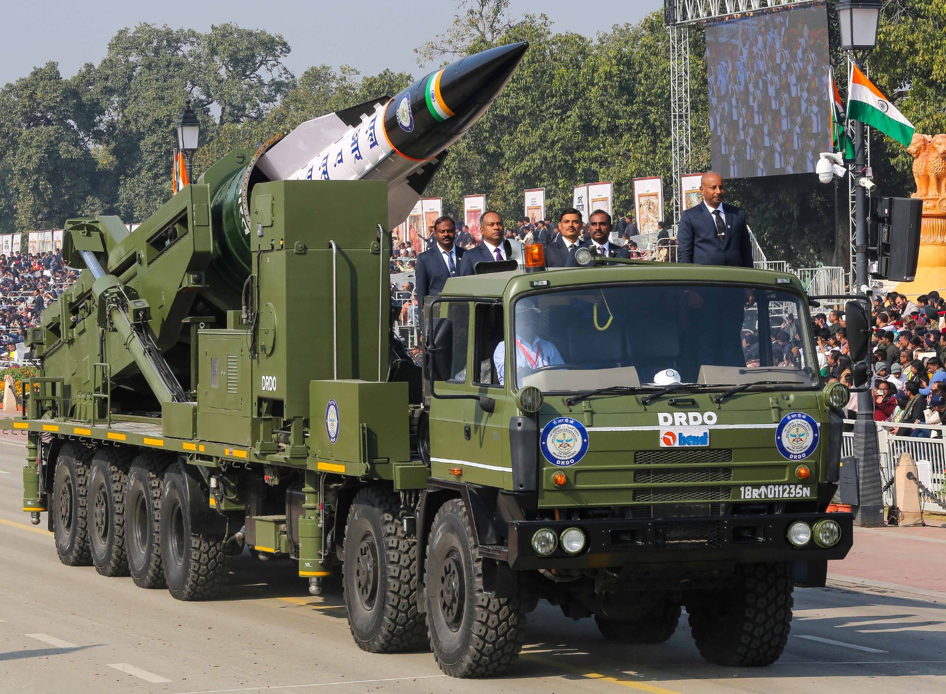
Indian World Class AAMs
India's primary indigenous AAM is the Astra, a family of Beyond Visual Range (BVR) missiles with variants like Mk-1 (110km range) and upcoming longer-range Mk-2 (160 km initially, upgrade to 240 km later) and Mk-3 “Gandiva” (350 km). These are being integrated on most Indian fighters, and already cleared on Su-30MKI, MiG-29, and Tejas Mk. 1/1A. DRDO scientists have also reportedly assessed technology from the Chinese-origin PL-15E missile that was recovered intact by India during Op Sindoor, as it lacked self-destruct technology. Mk3 uses Solid Fuel Ducted Ramjet (SFDR) and utilises a two-way data link for mid-course guidance from the launch aircraft or friendly AEW&C aircraft and employs electronic counter-countermeasures. Top global AAMs are MBDA Meteor (200+ km), AIM-120D AMRAAM (160+ km), French MICA (80 km), Russian R-77-1/R-77M (110-150 km), and Chinese PL-15 (180-200 km). Russian hypersonic R-37M (300 to 400 km) and American AIM-174B (400 km) are the longest range AAMs. India is reportedly acquiring the R-37M missile from Russia, with a make-in-India option.

Rudram Anti-Radiation Missile (ARM)
The Rudram missile series (I, II, III), developed by DRDO for the IAF, is evolving rapidly. Rudram-I is in production. Rudram-II (300 km range) was flight-tested in May 2024 and expected to gain production clearance by 2026. The long-range Rudram-III (550-600 km) has also completed successful tests in 2025. DRDO has also involved Adani Defence & Aerospace under the Development cum Production Partner programme for mass production. Launch platforms are MiG-29UPG, Dassault Mirage 2000, Su-30MKI, Tejas Mk1/1A, and Tejas Mk2 (Planned). These missiles are vital for Suppression of Enemy Air Defences (SEAD) missions, utilizing passive homing heads to identify, classify, and engage targets.

Hypersonic Technology Demonstrator Vehicle (HSTDV)
The HSTDV is an unmanned scramjet demonstration aircraft developed by DRDO to achieve hypersonic flight at speeds around Mach 6.5. Successfully tested, it utilizes a solid rocket motor to reach high altitudes and speeds, validating technologies like scramjet ignition, air-breathing propulsion, and high-temperature material resistance. The HSTDV has demonstrated Mach 6 speed and can reach altitudes of 30–32 km, crucial for high-speed cruise. The vehicle uses an indigenous air-breathing scramjet engine, which compresses air before combustion, making it more efficient and cost-effective than conventional rockets.
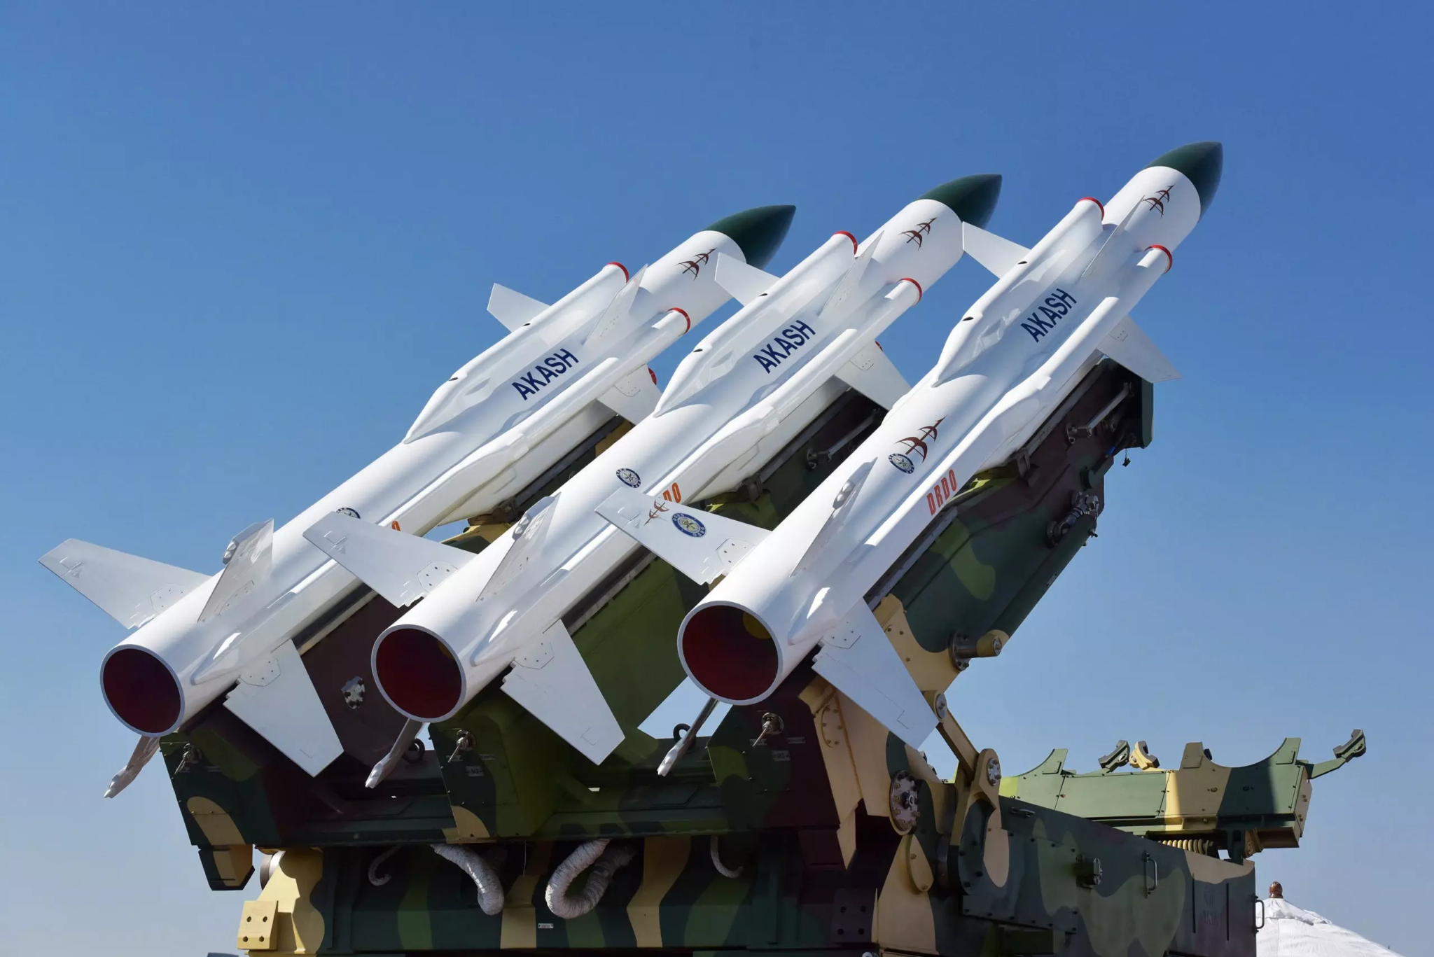

The technology is intended for developing long-range cruise missiles (like Brahmos II) and low-cost, reusable satellite launch vehicles. With its successful test, India became the fourth country (after the USA, Russia, and China) to demonstrate this technology, enhancing capabilities against missile defence systems. The vehicle utilizes advanced materials and thermal barrier coatings to withstand temperatures exceeding 2500 degrees Celsius. The HSTDV program marks a significant leap in India's defence, surveillance, and space launch capabilities.

A-SAT
On March 27, 2019, India successfully conducted Mission Shakti, an anti-satellite (ASAT) missile test, destroying a live, low-Earth orbit (LEO) satellite using a Kinetic Kill vehicle through a direct hit. Led by the DRDO, this made India the fourth nation, after the US, Russia, and China, to demonstrate this, boosting its space deterrence capability. The missile is a modified 3-stage DRDO interceptor missile with two solid rocket boosters. All parameters were achieved, making India a “space superpower”. It demonstrated sophisticated, indigenous, and highly precise space technology. It provides a “credible deterrent” against threats to India’s crucial space-based assets. The government maintains this is a defensive tool meant for peace and security, not for weaponising space. The test was deemed necessary to establish deterrence against adversaries in the region.

To Summarise
DRDO follows the principle “Balasya Mulam Vigyanam” that is “The source of strength is science”, on the premise that scientific development is fundamental to India’s national security. India has a great and growing package of indigenous missiles. The nation is using leading edge technologies and employs a blend of indigenous missiles (Astra, Rudram) and imported systems (like Russian & Israeli missiles) for a comprehensive air defence and offensive options. India continues to develop advanced AAMs, focusing on longer ranges (BVRAAM), faster engagement, and specialized roles like anti-radiation, ensuring its air combat capabilities remain potent. The range and accuracy are catching up with the best in the world. Indian missiles can operate in a dense EW environment, and their no-escape zones are increasing. It is a matter of time before India will reduce dependence on foreign weapons. Israel and Russia have been particularly supportive and have shared technologies through a joint venture route (BrahMos, MRSAM).

India is gradually switching from being a large arms-importing country to an inspiring defence manufacturer and exporter. The nation is rapidly expanding its defence footprint, driven by the export of indigenously developed, high-tech systems like the supersonic BrahMos cruise missile ($375M deal with the Philippines and the recent negotiations with Vietnam) and the Akash air defence system to Southeast Asian and African nations. Other nations interested in BrahMos include Malaysia, the UAE, Chile, and South Africa. Akash missile system is actively being exported, with Armenia being the first confirmed buyer in a major 2022 deal, and significant interest shown by countries like the Philippines, Brazil, Egypt, and Vietnam. India's defence exports reached an all-time high of ₹38,424 crore ($4.1 billion) in the financial year 2025-26, marking a 62.66% surge from the previous year.

Atmanirbharta is most important in defence technologies. Indigenization prevents supply chain vulnerabilities. While India has some distance to cover in aircraft, stealth, and aeroengines, the nation has done well in missiles. It is hoped that soon missiles will go on the Positive Indigenisation List (PIL). As of 2026, the Indian Military is transitioning from the “Cold Start” doctrine to the “Cold Strike” doctrine, focusing on proactive, multi-domain operations and rapid, precise punitive strikes rather than just seizing shallow territory. India’s missile program supports such actions.

